# **Deploy a container instance in Azure using the Azure portal**

Use Azure Container Instances to run serverless Docker containers in Azure with simplicity and speed. Deploy an application to a container instance on-demand when you don't need a full container orchestration platform like Azure Kubernetes Service.

In this Activity, you use the Azure portal to deploy an isolated Docker container and make its application available with a fully qualified domain name (FQDN). After configuring a few settings and deploying the container, you can browse to the running application:

## **Create a container instance**

1. On the Azure portal homepage, select Create a resource.
2. Select Containers > Container Instances
3. On the Basics page, choose a subscription and enter the following values for Resource group, Container name, Image source, and Container image.
4. Resource group: Create new > Batch_Name(Batch123_Naveen)
5. Container name: naveen
6. Image source: QuickStart images.

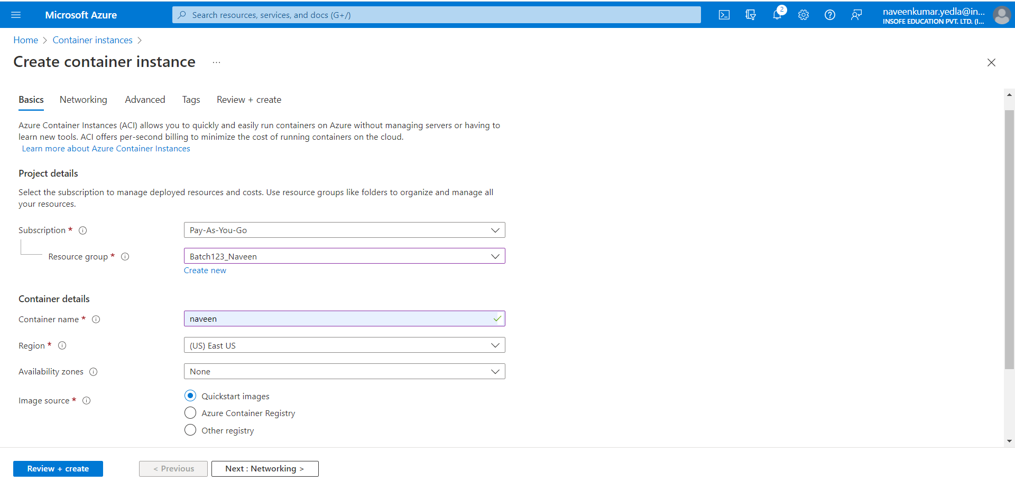

1. Leave all other settings as their defaults, then select Review + create.  
   When the validation completes, you're shown a summary of the container's settings. Select Create to submit your container deployment request.

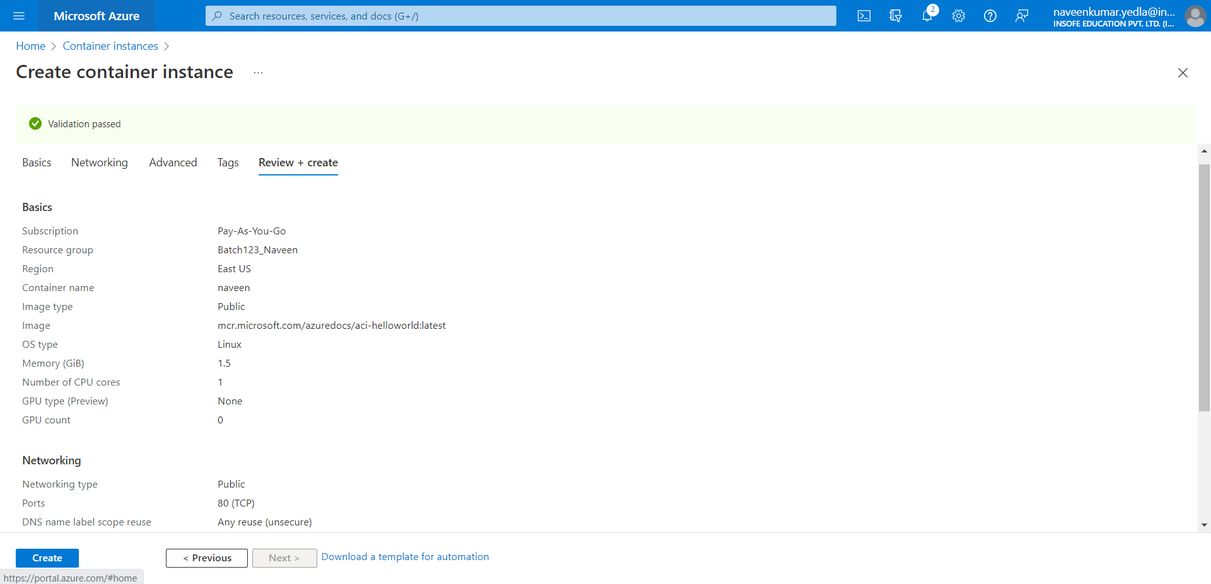

1. When deployment starts, a notification appears that indicates the deployment is in progress. Another notification is displayed when the container group has been deployed.

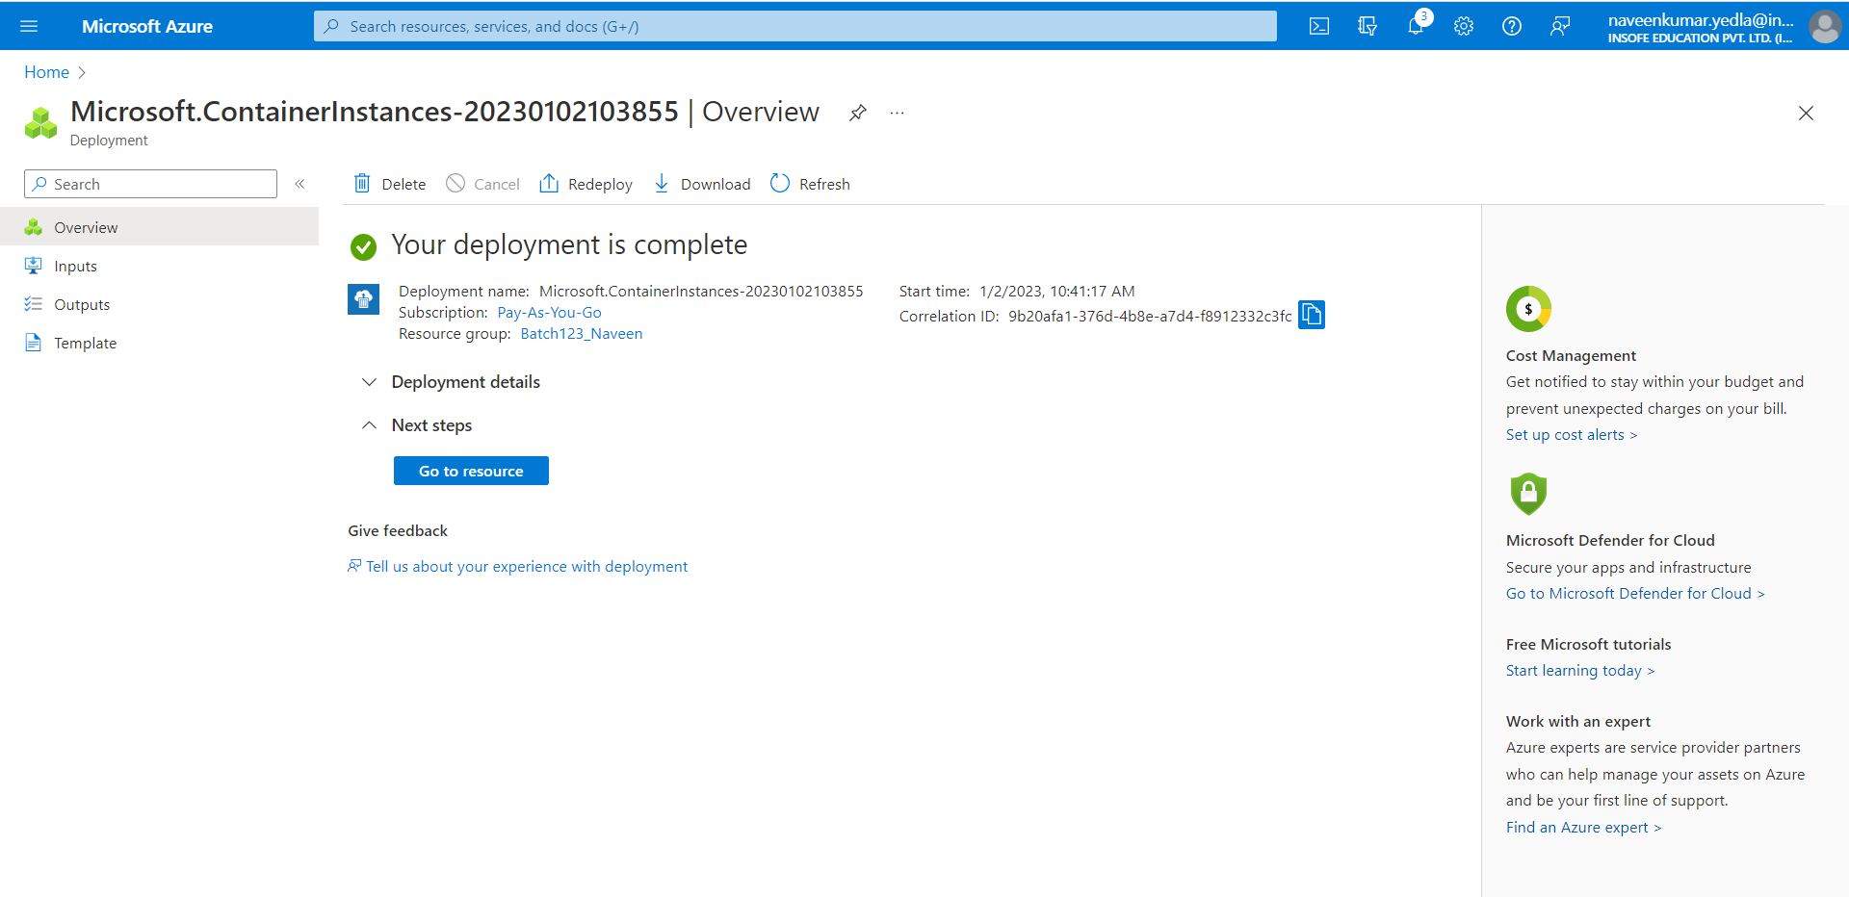

1. Once its Status is Running, navigate to the container's FQDN in your browser.

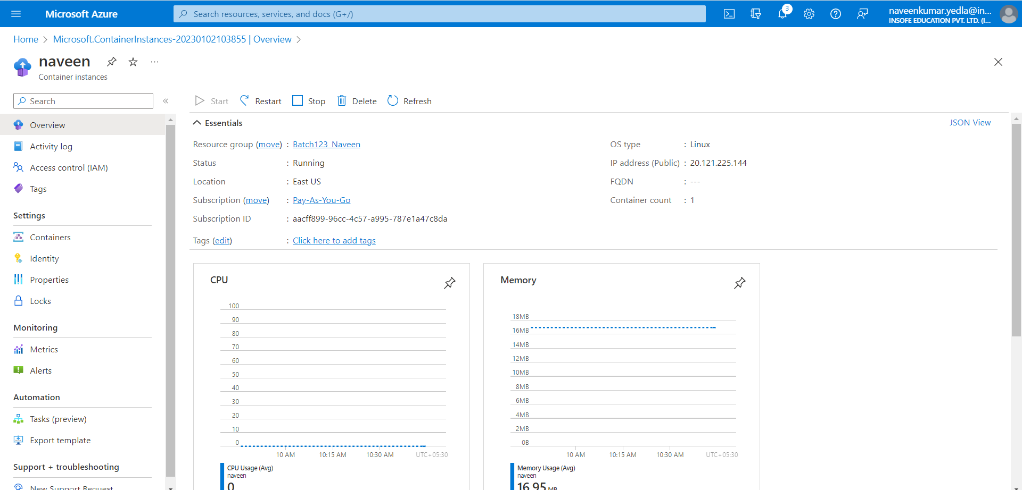

1. Copy IP address and paste it on browser. you've deployed a publicly accessible application in Azure Container Instances.

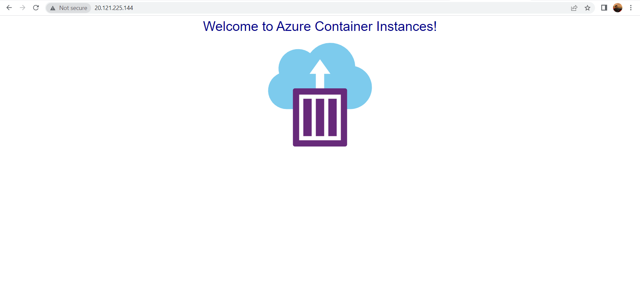

## **View container logs**

1. Viewing the logs for a container instance is helpful when troubleshooting issues with your container or the application it runs.
2. To view the container's logs, under **Settings**, select **Containers** > **Logs**. You should see the HTTP GET request generated when you viewed the application in your browser.

## **Clean up resources**

When you're done with the container, select Overview for the container instance, then select Delete.